**Data Definition Questions: (using SQL NOT GUI)**

1. Create a table named "Employees" with columns for ID (integer), Name (varchar), and Salary (decimal).

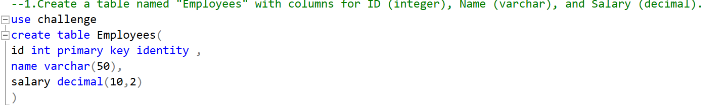

1. Add a new column named "Department" to the "Employees" table with data type varchar(50).

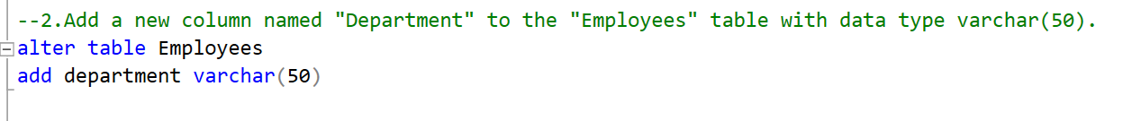

1. Remove the "Salary" column from the "Employees" table.

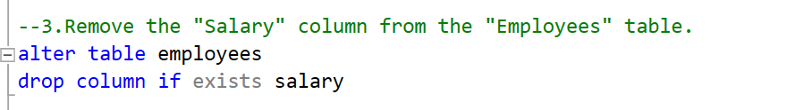

1. Rename the "Department" column in the "Employees" table to "DeptName".

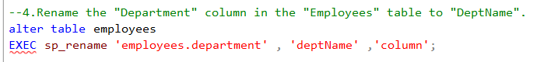

1. Create a new table called "Projects" with columns for ProjectID (integer) and ProjectName (varchar).

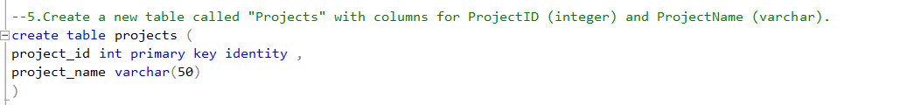

1. Add a primary key constraint to the "Employees" table for the "ID" column.

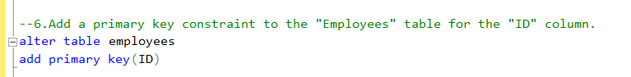

1. Add a unique constraint to the "Name" column in the "Employees" table.

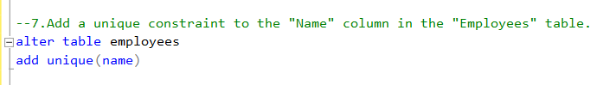

1. Create a table named "Customers" with columns for CustomerID (integer), FirstName (varchar), LastName (varchar), and Email (varchar), and Status (varchar).

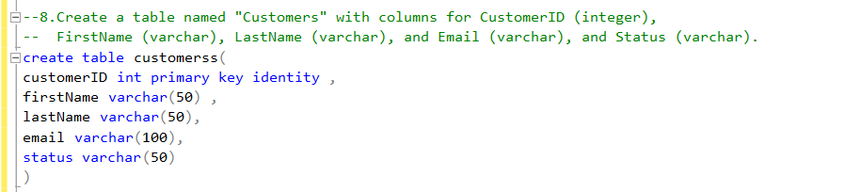

1. Add a unique constraint to the combination of "FirstName" and "LastName" columns in the "Customers" table.



1. Create a table named "Orders" with columns for OrderID (integer), CustomerID (integer), OrderDate (datetime), and TotalAmount (decimal).

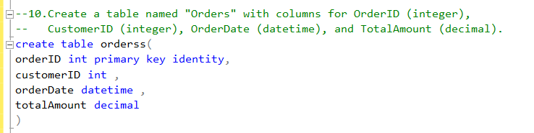

1. Add a check constraint to the "TotalAmount" column in the "Orders" table to ensure that it is greater than zero.

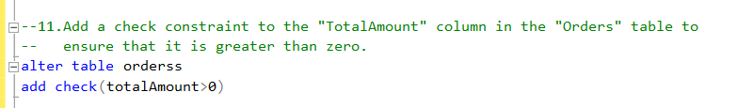

1. Create a schema named "Sales" and move the "Orders" table into this schema.

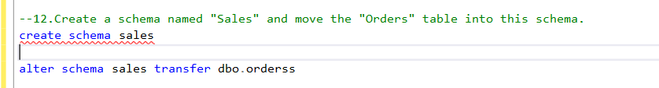

1. Rename the "Orders" table to "SalesOrders."

